GUEST LECTURES AND WORKSHOPS ORGANISED BY AND IN THE DEPARTMENT OF MSW (WEBINARS) FOR THE ACADEMIC YEAR 2020- 2021

GUEST LECTURE ON “EXPECTATIONS OF ORGANIZATIONS FROM SOCIAL DEVELOPMENT STUDENTS - LEARNING FROM BOTH CLASS ROOM AND PRACTICE”

The department of Social Work organized the Guest Lecture on “Expectations of Organizations from Social Development Students - Learning from both class room and practice” for II Year MSW student’s on18th September 2020 at 11AM. Mr. Lohit Y T, Assistant Manager, Wetlands Conservation, WWF India, Bangalore gave the lecture on prerequisites of Social Worker in Social Development field and current knowledge and skill expectations in job Market.

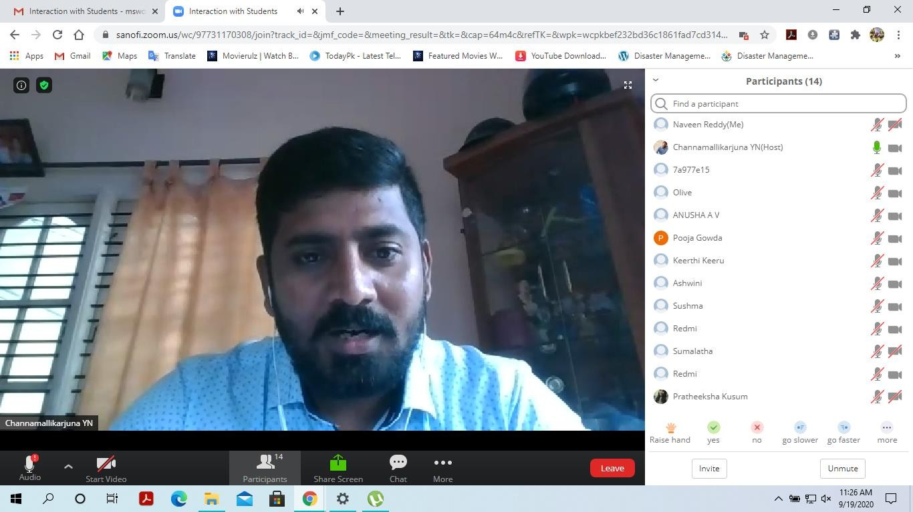

GUEST LECTURE ON “EXPECTATIONS OF ORGANIZATIONS FROM MPSW STUDENTS - LEARNING FROM BOTH CLASS ROOM AND PRACTICE”

The department of Social Work organized the Guest lecture on “Expectations of Organizations from MPSW Students - Learning from both class room and practice” for II Year MSW students on 18th September 2020 at 2 PM. Mrs. Vanishree, Free Lance, Bangalore threw light on the practical workability of professional knowledge base and skill set requirements of Medical and Psychiatric Social workers as expected in different Job settings.

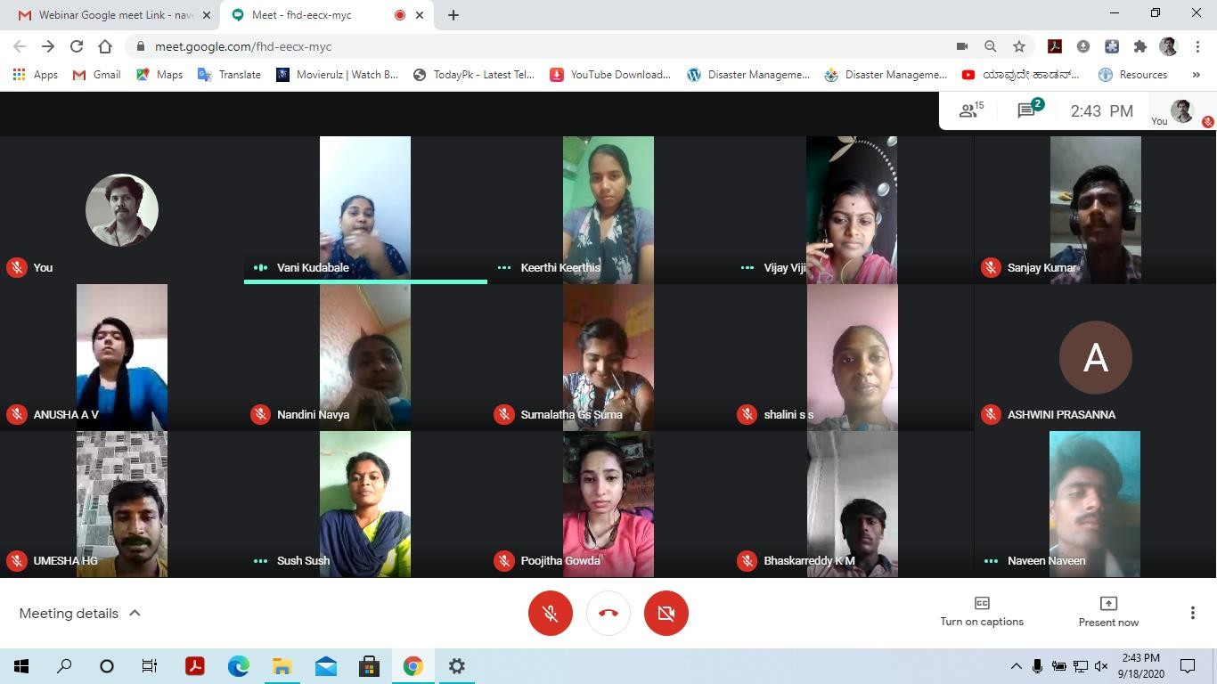

GUEST LECTURE ON “EXPECTATIONS OF ORGANIZATIONS FROM MPSW STUDENTS - LEARNING FROM BOTH CLASS ROOM AND PRACTICE”

The department of Social Work held the Guest lecture on “Expectations of Organizations from MPSW Students - Learning from both class room and practice” for our II Year MSW students on19th September 2020 at 11 AM. Mr. Channamallikarjuna Y.N, Sanofi, Bangalore the speaker for the guest lecture, imparted on scope of Medical and Psychiatric Social work in different settings and necessary skills sets required to perform duties.

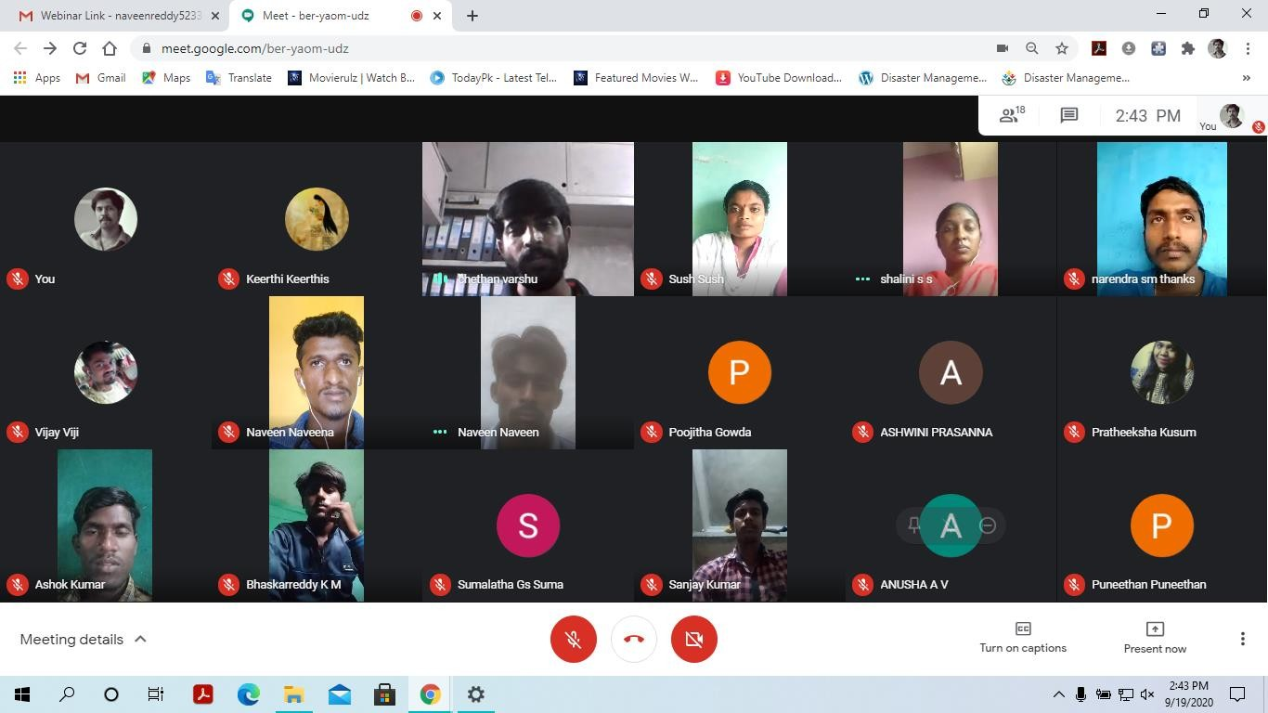

The department of Social Work organized the Guest lecture on “Expectations of Industries from MSW Students - Learning from both class room and practice” for our II Year MSW students on19th September 2020 at 2pm. Mr. Chethan, HR Assistant Manager, Olive life sciences, Bangalore in his talk stressed on the essentiality of Practice based knowledge, prerequisite skills to seek, attain and sustain relevant and apt positions in the professional field.

WEBINAR ON “CONSERVATION OF LAKES AND REDUCTION OF WATER FOOT PRINT”

The Department of Social Work has organized the Webinar on “Conservation of Lakes and Reduction of Water Foot Print” on June 7th 2021. The Resource person Mr. Lohit Y T, Assistant Manager at Wetland Conservation WWF India explained and showed different aspects in Lake Conservation and human initiative in this drive. The students of UG and PG the Oxford college of Arts have actively participated and utilized the session for knowledge gain.

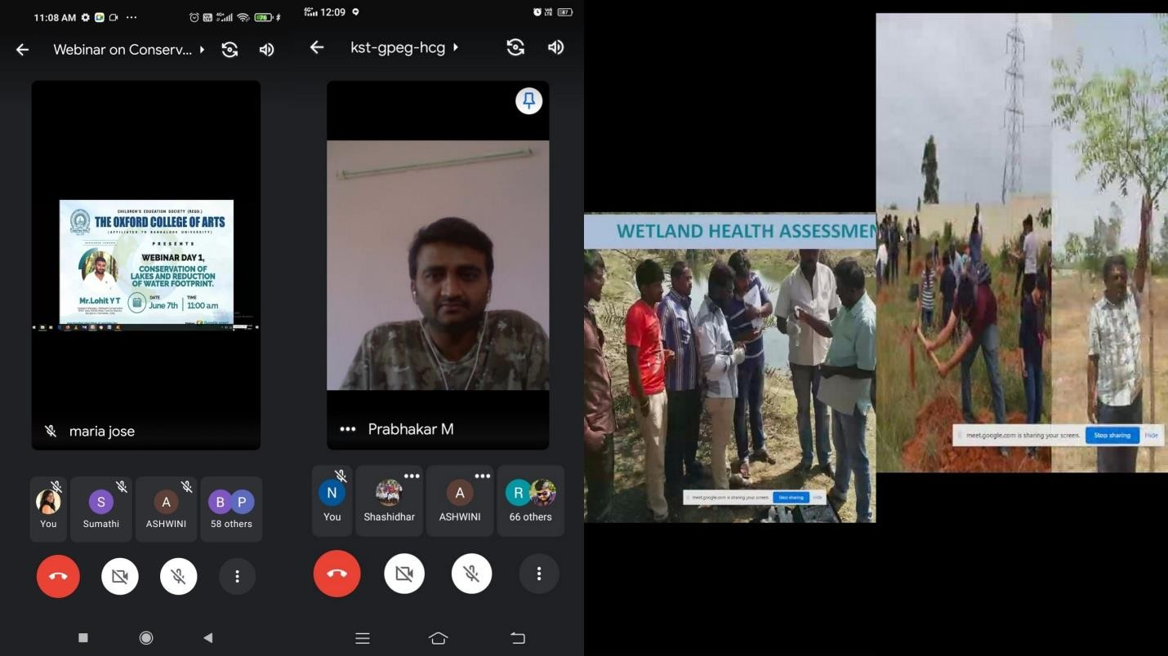

WEBINAR ON “URBAN BIODIVERSITY AND CURRENT SCENARIO”
The Department of Social Work has organized the Webinar on “Urban Biodiversity and Current Scenario” on June 8th 2021. The Resource person Chinmay C Maliye, Amateur Naturalist described the Urban Bio diversity and Current Scenario in Indian cities. The students of UG and PG the Oxford college of Arts have actively participated.

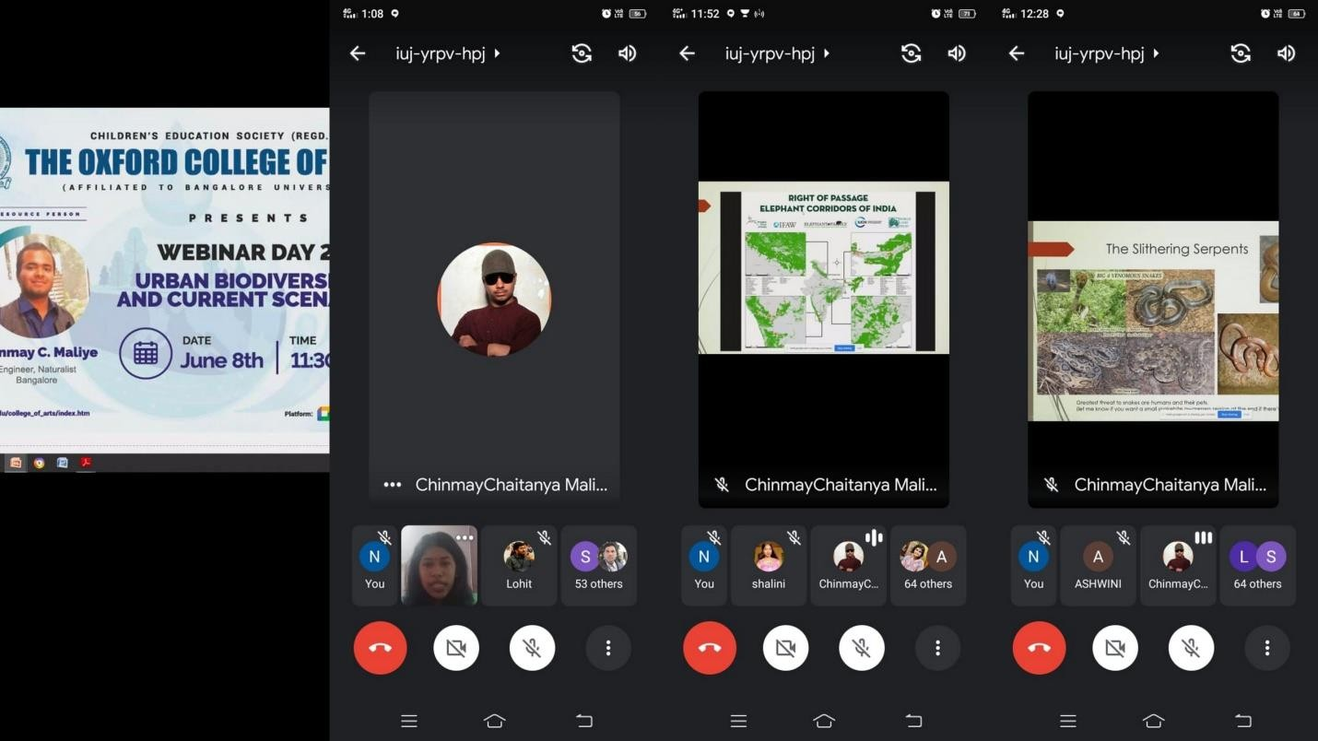

WEBINAR ON "CHILD LABOUR- ISSUES AND CONCERNS-ROLE OF SOCIETY”
The Department of Social Work, The Oxford College of Arts (TOCA) has organized Webinar on the topic titled "Child labour- Issues and concerns-Role of society” on 9th July 2021 from 12 noon to 1 pm. Dr Vani kantli -Freelancer (Former program co-ordinator – Bachpan Bachao Andholan) the resource person for the webinar threw light on prevalent Child Labour issues with various case discussions. Mrs. vani imparted on meaning and legal safeguards for child labour and stressed on alertness on this issue. Participants queried of doubts on the some issues of the topic. All the students of The Oxford College of Arts actively taken part in the webinar session and made it successful.
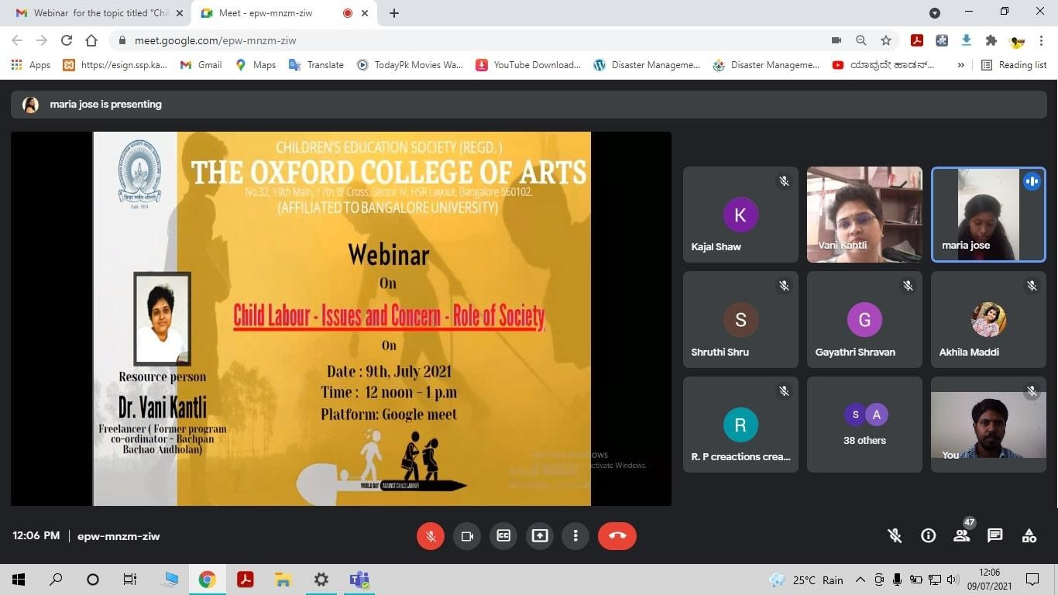
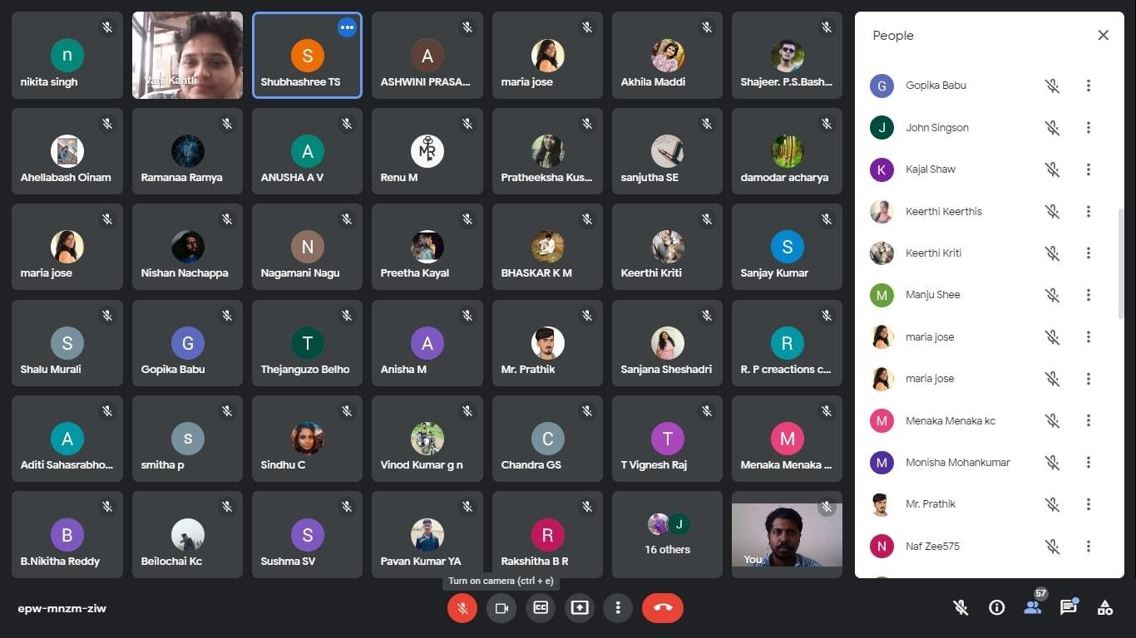

WEBINAR ON GENDER SENSITISATION

The Department of Social Work organised the Webinar on Gender Sensitisation on 22nd July 2021. Resource Persons, Mrs. Celin Suguna, Mrs Amelia Chandru and Ms Vidushi, of Vimochana- A Forum for Women’s Rights conducted the awareness and interactive session for the students of the College.

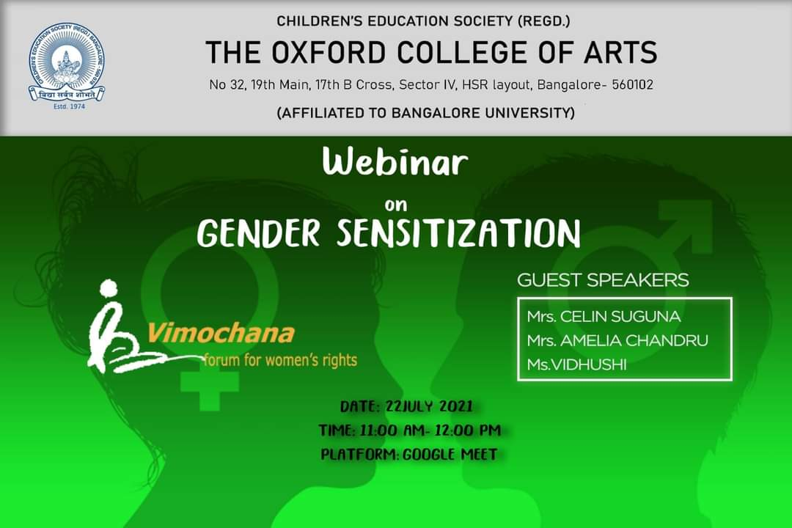
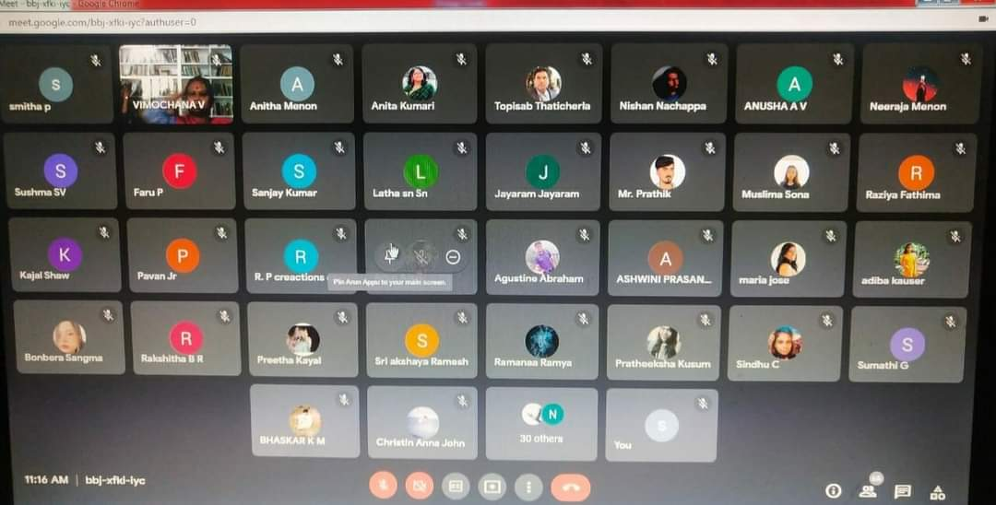

WEBINAR ON MENSTRUAL HEALTH AND HYGIENE

The Department of Social Work organised webinar on Menstrual Health and Hygieneon 20th July 2021. The session was conducted by the Resource Person Ms. Ankita Sukhwal CSR Executive, Unicharm India. All the Students from PG and UG of The Oxford College of Arts participated in the awareness Webinar.

